Joel Edwards
Course: Java Programming 2
Homework 3
October 2, 2011

I created the Main class to perform the operations specified in the homework description. I created a MySQL database in order to perform the tests. I used the JDBC MySQL driver to connect to the database.

The output from the final run can be seen in Illustration 1.

Source:

Main.java:
import java.sql.Connection;
import java.sql.Driver;
import java.sql.DriverManager;
import java.sql.PreparedStatement;
import java.sql.ResultSet;
import java.sql.SQLException;
import java.sql.Statement;
import java.util.Enumeration;
import java.util.HashMap;
import java.util.Random;
import java.util.Set;

public class Main
{
// Information for the database in a raw format.
public static final String contacts[] = {
"Rev.,Joel,David,Edwards,,555.728.2556,Mobile,555.873.2912,Work,555.823.0449,Home",
",Robert,,Paulson,,555.471.2208,Work,555.143.3444,Mobile",
",Charles,Daniel,Xavier,Ph.D,555.226.2818,Work,555.853.2266,Mobile"
};

public static void main(String argv[])
{
Connection conn = null;
PreparedStatement stmt = null;
ResultSet results = null;
ResultSet ids = null;
String value = null;

// Load the MySQL JDBC driver
try {
Class.forName("com.mysql.jdbc.Driver");
} catch (ClassNotFoundException ex) {
System.out.printf("Could not load MySQL driver.", ex);
System.exit(1);
}

// Print a list of the available drivers
System.out.printf("Available Drivers:\n");
Enumeration<Driver> drivers = DriverManager.getDrivers();
Driver d = null;
while (drivers.hasMoreElements()) {
d = drivers.nextElement();
System.out.printf(" %s\n", d.toString());
}
System.out.print("\n");

try {
// Establish a connection to the database
System.out.print("1.a) Connecting to the database...");
conn = DriverManager.getConnection(
"jdbc:mysql://localhost/test?" +
"user=test&password=test");
System.out.print("Done.\n");

// Get rid of the tables from the last run
// but only if they exist
System.out.print("1.b) Removing any test tables...");
stmt = conn.prepareStatement(
"DROP TABLE IF EXISTS Contact, Phone;");
stmt.execute();
System.out.print("Done.\n");

// Create the fist table
System.out.print("2) Creating the first table (Contact)...");
stmt = conn.prepareStatement(
"CREATE TABLE IF NOT EXISTS Contact (" +
"id INTEGER NOT NULL AUTO_INCREMENT PRIMARY KEY," +
"first VARCHAR(64) NOT NULL," +
"last VARCHAR(64) NOT NULL," +
"middle VARCHAR(64)," +
"prefix VARCHAR(32)," +
"suffix VARCHAR(32)," +
"UNIQUE (first, last, middle)" +
");");
stmt.execute();
System.out.print("Done.\n");

// Popuate the first table with data
System.out.print("3) Populating the first table (Contact)...");
HashMap<Integer,HashMap<String,String>> numbers;
numbers = new HashMap<Integer,HashMap<String,String>>();

// Generate a prepared statement which can be re-used
// for each insert operation.
stmt = conn.prepareStatement(
"INSERT " +
"INTO Contact(prefix, first, middle, last, suffix) " +
"VALUES (?, ?, ?, ?, ?)",
Statement.RETURN_GENERATED_KEYS);

// Loop through the raw data, extract the person's name
// and their phone numbers
for (String info: contacts) {
// Ensure that we have sufficient data to
// populate the person's name
String[] parts = info.split(",");
if (parts.length < 5) {
continue;
}

// Track the number of values processed for this contact
int processed = 0;
// Add individual column values to the prepared statement
for (int i = 0; i < 5; i++) {
value = parts[i].trim();
stmt.setString(i+1, value);
}
stmt.executeUpdate();

// Extract the id for the inserted row
ids = stmt.getGeneratedKeys();
ids.next();
int id = ids.getInt(1);
processed = 5;
String number;
String desc;

// Pair the stored ID with the remaining values
// from this contact.
HashMap<String,String> phones;
phones = new HashMap<String,String>();
while ((processed + 2) <= parts.length) {
number = parts[processed];
desc = parts[processed+1];
phones.put(number, desc);
processed += 2;

}
numbers.put(id, phones);
}
System.out.print("Done.\n");

// Dump the contents of the fist table to verify
// that it was correctly created and populated
System.out.printf("4) Checking the table's contents:\n");
stmt = conn.prepareStatement("SELECT * FROM Contact;");
results = stmt.executeQuery();
int row = 0;
while (results.next()) {
System.out.print(" >");
for (int i = 1; i < 20; i++) {
// For a simple inplementation such as this we can
// simply check up to 20 columns, and try to extract
// the data in first string then integer format,
// stopping once neither works.
try {
value = results.getString(i);
if (value.length() > 0) {
System.out.printf(" %s", value);
}
}
catch (SQLException ex) {
try {
System.out.printf(" %d", results.getInt(i));
}
catch (SQLException ex2) {
continue;
}
}
}
System.out.print("\n");
}

// Update the first table with an additional
// person's information
System.out.print("5) Updating the first table (Contact)...");
stmt = conn.prepareStatement(
"INSERT IGNORE " +
"INTO Contact(prefix, first, middle, last, suffix) " +
"VALUES (?, ?, ?, ?, ?)",
Statement.RETURN_GENERATED_KEYS);
stmt.setString(1, "");
stmt.setString(2, "Lind");
stmt.setString(3, "");
stmt.setString(4, "Gee");
stmt.setString(5, "Ph.D");
stmt.executeUpdate();
System.out.print("Done.\n");

// Dump the contents of the fist table to verify
// that it was correctly updated
System.out.printf("6) Checking the table's contents:\n");
stmt = conn.prepareStatement("SELECT * FROM Contact;");
results = stmt.executeQuery();
row = 0;
while (results.next()) {
System.out.print(" >");
for (int i = 0; i < 20; i++) {
try {
value = results.getString(i);
if (value.length() > 0) {
System.out.printf(" %s", value);
}
}
catch (SQLException ex) {
try {
System.out.printf(" %d", results.getInt(i));
}
catch (SQLException ex2) {
continue;
}
}
}
System.out.print("\n");
}

// Create the second table
System.out.print("7.a) Creating the second table (Phone)...");
stmt = conn.prepareStatement(
"CREATE TABLE IF NOT EXISTS Phone (" +
"number VARCHAR(64) NOT NULL PRIMARY KEY," +
"description VARCHAR(64) NOT NULL," +
"contact_id INTEGER NOT NULL" +
");");
stmt.execute();
System.out.print("Done.\n");

// Generate a prepared statement which can be re-used
// for each insert operation
stmt = conn.prepareStatement(
"INSERT IGNORE " +
"INTO Phone(number, description, contact_id) " +
"VALUES (?, ?, ?)");

// Insert values into the second table
System.out.print("7.b) Populating the second table (Phone)...");
Set<Integer> keys = numbers.keySet();
for (Integer id: keys) {
HashMap<String,String> numList = numbers.get(id);
Set<String> types = numList.keySet();
// Add individual column values to the prepared statement
for (String number: types) {
stmt.setString(1, number);
stmt.setString(2, numList.get(number));
stmt.setInt(3, id);
stmt.executeUpdate();
}
}
System.out.print("Done.\n");

// Dump a join of both tables to confirm that all data
// was added, and they were correctly tied together.
System.out.print("8) Verifying all contact info (join):\n");
stmt = conn.prepareStatement(
"SELECT * " +
"FROM Contact " +
"INNER JOIN Phone " +
" ON Contact.id = Phone.contact_id;"
);
results = stmt.executeQuery();
row = 0;
while (results.next()) {
System.out.print(" >");
row = results.getRow();
for (int i = 0; i < 20; i++) {
try {
value = results.getString(i);
if (value.length() > 0) {
System.out.printf(" %s", value);
}
}
catch (SQLException ex) {
try {
System.out.printf(" %d", results.getInt(i));
}
catch (SQLException ex2) {
continue;
}
}
}
System.out.print("\n");
}

conn.close();
} catch (SQLException ex) {
System.out.printf("Caught SQLException: %s\n", ex);
System.out.printf("\n");
System.exit(1);
}

}
}

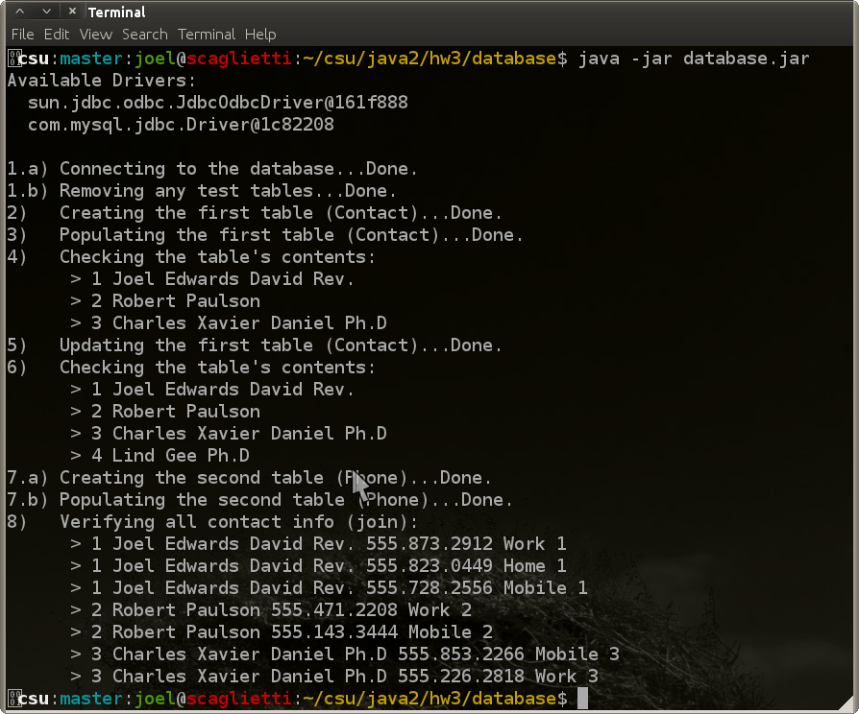Illustration 1: Results of Program Run

